Sister Dorothy Stang Novena (February 4-12)

Abstract 1
Dorothy Stang Novena: Day 1 2
Dorothy Stang Novena: Day 2 3
Dorothy Stang Novena: Day 3 5
Dorothy Stang Novena: Day 4 6
Dorothy Stang Novena: Day 5 8
Dorothy Stang Novena: Day 6 10
Dorothy Stang Novena: Day 7 11
Dorothy Stang Novena: Day 8 13
Dorothy Stang Novena: Day 9 15

Abstract
Abstract: Thank you for joining us as we remember Sister Dorothy Stang, who was murdered February 12, 2005 in Brazil.
Content: Thank you for joining us as we remember Sister Dorothy Stang, who was murdered February 12, 2005 in Brazil. We hope these nine days of reflection on the Beatitudes provides both heart-affirming words and ideas for ways that we can bring more peace and justice in the world.

Dorothy Stang Novena: Day 1
February 4
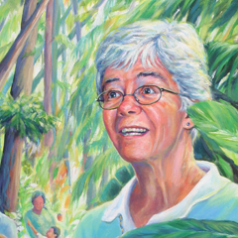
Blessed are the poor in spirit; the reign of God is theirs. Matthew 5:3
"If we strip ourselves of all our extras that consume so much of our time and thoughts…our left-over time is no longer colored and it is no longer hard to give a Gospel response." — Sister Dorothy Stang
What is "poor in spirit?" For me it has a great deal to do with the treasure of time. Used wisely, for the benefit of loved ones and friends it becomes a means of healing, hope, laughter—a blessing for us as well as for others. But we can find ourselves so preoccupied with work, responsibilities and dealing with "things" that we have little energy left for quality time with family and friends--and for quiet.
Sister Dorothy would say: "STOP! Give yourself space to smell the flowers and marvel at nature." She would invite us away from preoccupation with ourselves to give time to those in need. She would say: "Remember that you have a special Friend who wants to spend time with YOU!"
Dorothy always carried her Bible with her. It was well-worn, taken on long walks to remote villages in the woods, with her as she slept overnight in an office where the official purposely delayed seeing her. "Over time it is no longer hard to give a Gospel response," she said. "We can prioritize time for ourselves. We can modify our busyness and lighten the burden of too many things." We can make time to be with the One who is always present to us. Thus poverty of spirit becomes transformed in time into the richness of pure gold.
Prayer:
Generous and compassionate God, Help me to learn how to simplify and focus my life in order to be more available to others. Increase my consciousness of your Presence in my life. Amen.
Action:
Sister Dorothy loved nature. Take time this week to marvel at the beauty of nature.

Dorothy Stang Novena: Day 2
February 5
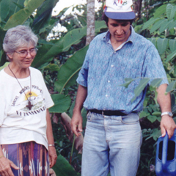
Blessed are the sorrowing; they shall be consoled. Matthew 5:4
"I don't want to flee, nor do I want to abandon the battle of the farmers who live without any protection in the forest." — Sister Dorothy Stang
Jesus
Jesus –
a man the children
loved,
a kind man
who healed and freed
the lame to walk again
and the blind to see,
who consoled the sorrowing.
He was a quiet man
enraged
by money changers in his Father’s temple,
by their arrogance and grabbing asperity,
by the stink of sickened animals.

Dare I be like him –
loved
kind
a consoler –
and enraged?

Action:
Sister Dorothy Stang practiced simple kindness every day. Look around your small world. Where is kindness needed? Consolation? Today offer a small kindness or consolation in a place where it is needed.

Dorothy Stang Novena: Day 3
February 6
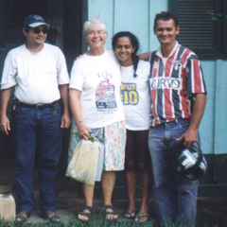
Blessed are the lowly: they shall inherit the earth. Matthew 5:5
"We need to be poor with the poor and re-appropriate a kind and tender relationship with Mother-Earth. Then we will know how to act." — Sister Dorothy Stang
Dorothy, your kind and tender relationship with the earth was engendered in you by your father who taught you to love the earth, smell its warm, rich soil and rejoice in what it produced. From your mother, you learned love and generosity for those who have less.
We give thanks for Christian parents who model faith and generosity in their children and encourage the path to their state in life.
Your wisdom of sustainable farming has gone far from the land of Ohio, to the richness of the Amazon.
Prayer:
We pray that those who work with the land--from the Ohio Valley, to the fertile fields of California, Florida and Brazil--be treated justly and with respect.
Action:
Today, plant something; a seed or hope in someone's heart. Enjoy a delicious fruit given to you by "Mother Earth who is so tender and kind."
Dorothy Stang Novena: Day 4
February 7
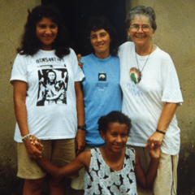
Blessed are they who hunger and thirst for justice; they shall have their fill. Matthew 5:6
"Our Gospel response calls us to take risks among our people. They don't have this privilege or they would be killed if they resist openly --indeed, they are killed." — Sister Dorothy Stang
On justice:
Sister Dorothy had a passion for justice expressed over almost 40 years of struggle for the poor farmers and for the integrity of the rainforest. Hundreds of people lost their lives, their homes, their crops and animals to the violence of illegal ranchers and loggers, but she doggedly pushed on. She knew the risks she was taking, living as she did with constant death threats, knowing that there was a $25,000 bounty on her head.
We can take a lesson from the Brazil story. We must not give up in our desire to see justice done in our own country. We may not have death threats, but working for justice and peace never lets up. Let us patiently work with issues, though they may not be resolved in our lifetimes. Courage and patience to keep on keeping on is a gift of grace.
"Felicio, don’t ever give up, do you hear me? You have to keep up the fight. You mustn’t abandon our people, do you understand? You must keep on fighting because God is with you." (Dorothy, speaking on the telephone to a young federal prosecutor, a supporter of the farmers, from Belem, on the morning of her assassination, February 12, 2005, as quoted in "The Greatest Gift—The Courageous Life and Martyrdom of Sister Dorothy Stang," by Binka Le Breton.)
Prayer:
Good and gracious God, we pray for the safety of our Sisters in Brazil. We pray for the people for whom they continue the dangerous work of accompaniment. We pray for the indigenous Sisters and Affiliates. We ask that you change the hearts of those who perpetuate violence in Anapu. We pray for ourselves as well that we be faithful to the practice of justice and peace in our communities, on behalf of the needs in our country, in responding to global needs. Amen.
Action:
Learn and respond about the conflict over the Belo Monte dam in Brazil that will destroy over 400,000 acres of rainforest and displace over 40,000 people.

Dorothy Stang Novena: Day 5
February 8
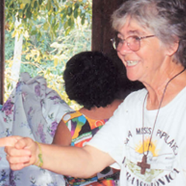
Blessed are they who show mercy; mercy shall be theirs. Matthew 5:7
"We can’t talk about the poor. We must be poor with the poor and then there is no doubt how to act." — Sister Dorothy Stang
Prayer (Reflection on Psalm 125):
You surround us like mountains
you keep us safe and secure.
When we trust you, we, too, are like the mountains
unshakable and enduring.

You are strength.
You are protection.
You are mercy.

You offer your riches to every one of us –
rich, poor, believer, non-believer
we are one in your heart.
Help us give, in turn, to others.

Peace be upon all people.

Action:
The gifts of this earth are for everyone. Do you have more than you need? This week sort through your excess and donate something to a charity that serves the poor.

Dorothy Stang Novena: Day 6
February 9
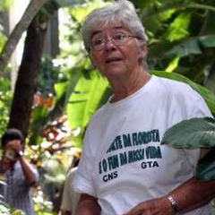
Blessed are the single-hearted: for they shall see God. Matthew 5:8
"I know they want to kill me, but I will not go away. My place is here alongside these people who are constantly humiliated by persons who consider themselves powerful." — Sister Dorothy Stang
Dorothy, your single-heartedness came from always keeping your gaze on Jesus crucified. This gave you courage to forge ahead when meeting opposition on every side.
Prayer:
Jesus, you too were constantly humiliated and challenged by the powerful. Yet, you always spoke the Truth. We ask for the grace to speak up on behalf of the powerless. We pray for the grace to continue to "see," understand and act on behalf of environmental justice especially in our own corner of the world.
Action:
Take time to listen to nature communicating with you. Delight in a bird’s song. Stand still and feel the wind caress your face. Look at and be bathed by the beauty of a sunset. What in your life needs to be reconciled?

Dorothy Stang Novena: Day 7
February 10
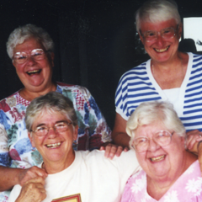
Blessed are the peacemakers; for they shall be called children of God. Matthew 5:8
"We are a global people–one family. A deep Christian value is sharing. I am an instrument to help them come together. I am a person free to do that." — Sister Dorothy Stang
Peacemaking
Walking around the campus of Notre Dame de Namur University I sing in my heart to see the different nationalities and cultures represented in the present student body. Our campus, and the state of California, exhibits the dramatic changes that have taken place since World War II. This generation is truly blest and the opportunity to build a world community has never been stronger or more important.
In 1992, Dorothy experienced a sense of this world community when she was invited to be a delegate to the United Nations Earth Summit in Rio. There she met other "green" advocates from around the world. "She returned to Anapu bursting with passion and full of fresh ideas. The world was finally concerned about the destruction of the rainforests around the globe—or so she thought. She spoke enthusiastically in the villages and communities." (Excerpt from: "A Journey of Courage: The Amazing Story of Sister Dorothy Stang" by Michele Murdock)
Prayer:
Who will speak for the poor and the broken and for the peoples oppressed? Who will speak so these voices are heard? Who will speak if we don't? Who will care for the forests and the creatures? Who will protect the precious land, the great rivers, the birds and the plants? Who will speak if we don’t?
I can be an instrument of justice and peace. I am a person free to do that.
Action:
Learn more about why the rainforest is being destroyed in Brazil.

Dorothy Stang Novena: Day 8
February 11
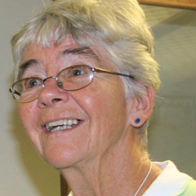
Blessed are those persecuted for holiness' sake; the reign of God is theirs. Matthew 5:10
"I light a candle and look at Jesus on the cross and ask for the strength to carry the suffering of the people. Don't worry about my safety. The safety of the people is what's important." — Sister Dorothy Stang
Prayer (Reflection on Psalm 130):
Out of the depths, I call to you –
out of the hunger of the poor, out of their thirst
out of their dying
out of the fear of families forced
from their homes and farms
out of the patience of those
working for justice.
May your ears be attentive to my cry for mercy.
Hear my cry!

If you mark our sins, who can stand?
If you mark our greed and restless search
for more than what we need?
If you mark our silent complicity in the wars
of our world?
If you mark our racism and tribalism
however crude or subtle?
But with you is forgiveness
and in forgiveness is our healing
for to be forgiven is to learn to forgive.

We wait with longing for you.
We wait for your healing words.
More than sentinels for daybreak, we look for you.

For with you is kindness and full redemption.
You will redeem us from our darkness.

Action:
Dorothy stepped out of her secure American mid-western world to accompany the farmers of the Amazon. What small step can you take outside of your comfort zone to accompany someone in need?

Dorothy Stang Novena: Day 9
February 12
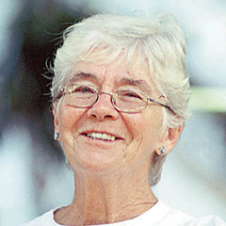
Blessed are you when they insult you and persecute you and utter every kind of slander against you because of me. Be glad and rejoice, for your reward is great in heaven. Matthew 5:11
"My heart screams joy. But I need patience as it (reform) can't happen overnight. How to maintain hope has been a challenge. I have to be with these people. If it means my life, I want to give my life."— Sister Dorothy Stang
Dorothy, they did speak lies about you, and persecute you and eventually murder you. They tried to silence you, but through your death, you became the "seed that fell to the ground." And your passion for the earth and love for the poor has sprouted! Your life and work are known worldwide and continue to provide a spotlight on injustice in the rainforest and be an inspiration to many.
Prayer:
We pray for the strength to stand with our sisters and brothers in Brazil through prayer, advocacy and action.
Action:
Ask yourself: "Am I living simply and not taking from the earth more than I need?" Think of one thing you can change that will be gentler on the earth.

